In vb van word

Userform invoegen en dan 4 textvakken , 3 knoppen en 4 labels inzetten

Om de code van die knoppen te hebben dubbelklik je op een butten in de userform1

Private oVars As Variables

Private Sub CommandButton1_Click()

'okee

'Define the variable oVars

Set oVars = ActiveDocument.Variables

Dim strPath As String

strPath = Mid(ActiveDocument.Name, 1, Len(ActiveDocument.Name) - 4)

'MsgBox (oVars("mem1").Value)

'Hide the userform

Me.Hide

oVars("artikelnaam").Value = Me.TextBox1.Value

'oVars("letref").Value = Me.TextBox2.Value + "-" + Me.TextBox3.Value + Me.TextBox4.Value

oVars("letref").Value = Me.TextBox2.Value + "-" + Left(strPath, 9) + Me.TextBox4.Value

oVars("letref").Value = UCase(oVars("letref").Value)

oVars("filenaamzonderextentie").Value = strPath

oVars("var4").Value = Me.TextBox4.Value

ActiveDocument.Fields.Update

'Clear the variable

Set oVars = Nothing

'Unload the form

Unload Me

End Sub

Private Sub CommandButton2_Click()

'Unload the form

Unload Me

End Sub

Private Sub CommandButton3_Click()

'MsgBox ("debug")

'("C:\Users\vth\Desktop\msoft.xlsx")

'https://social.msdn.microsoft.com/Forums/en-US/62fceda5-b21a-40b6-857c-ad28f12c1b23/use-excel-vba-to-open-a-text-file-and-search-it-for-a-specific-string?forum=isvvba

Dim strPath As String

strPath = Left(ActiveDocument.Name, 9)

'MsgBox (strPath)

Const strFileName = "C:\Users\VTH\Desktop\template2018\logfiles\msoftdb.txt" ' = via msoft naar excel en dan opslaan als txt

' strSearch = "strPath"

Dim strLine As String

Dim f As Integer

Dim lngLine As Long

Dim blnFound As Boolean

f = FreeFile

Open strFileName For Input As #f

Do While Not EOF(f)

lngLine = lngLine + 1

Line Input #f, strLine

If InStr(1, strLine, strPath, vbTextCompare) > 0 Then

' MsgBox "Search string found in line " & lngLine, vbInformation

' MsgBox (strLine)

'we moeten split doen op tab

Dim WrdArray() As String

'splitsen op tab

WrdArray() = Split(strLine, vbTab)

Me.TextBox1.Value = WrdArray(0)

Me.TextBox2.Value = WrdArray(1)

Me.TextBox3.Value = WrdArray(2)

'Define the variable oVars

Set oVars = ActiveDocument.Variables

'Hide the userform

Me.Hide

oVars("filenaamzonderextentie").Value = strLine

oVars("artikelnaam").Value = Me.TextBox1.Value

oVars("letref").Value = Me.TextBox2.Value + "-" + Me.TextBox3.Value

'oVars("filenaamzonderextentie").Value = strPath

ActiveDocument.Fields.Update

blnFound = True

Exit Do

End If

Loop

Close #f

If Not blnFound Then

MsgBox "ep , hf en hfpri uit msoft halen ,via excel en in msoft.txt zetten", vbInformation

Me.TextBox1.Value = "letomschr. niet gevonden"

End If

'verpakkingslabel genereren in nummers.txt

'printen naar file ?C:\Users\VTH\Desktop\nummers.txt

map = "C:\Users\VTH\Desktop\"

bestand = "nummers.txt"

Dim strFile_Path As String

strFile_Path = map & bestand

Open strFile_Path For Output As #1

'Print #1, "proj" & ActiveSheet.Range("a1").Value

Print #1, Me.TextBox1.Value & "!" & Me.TextBox2.Value + "-" + Me.TextBox3.Value

'file sluiten en vrijgeven

Close #1

'einde 'verpakkingslabel genereren in nummers.txt

'Unload the form

Unload Me

End Sub

Private Sub TextBox5_Change()

End Sub

Private Sub UserForm_Initialize()

Me.Caption = "My Produktievoorschrift wizard"

Me.Label1.Caption = "artikelnaam"

Me.Label2.Caption = "prefix"

Me.Label3.Caption = "LETnummer"

Me.Label4.Caption = "suffix"

Me.CommandButton1.Caption = "OK"

Me.CommandButton2.Caption = "Cancel"

Me.CommandButton3.Caption = "via msoft.txt + verpakkingslabel in nummers.txt"

End Sub

Dan plak je deze code die uit msoftdb een koptext zet in een pv

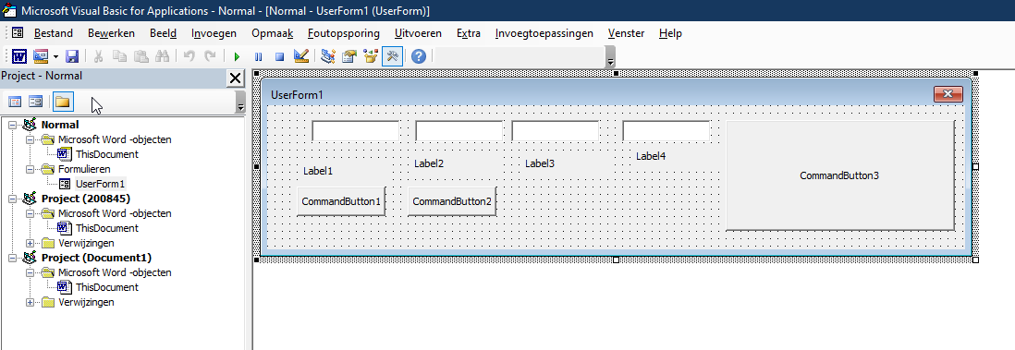

Dan de code van psp voor refresh enzo te doen

In normal , dubbelklik op thisdocument

En daarin deze code zetten van psp

Sub ProduktievoorschriftWizard()

UserForm1.Show

Unload UserForm1

End Sub

Sub UpdateAllFields()

Dim oStory As Range

For Each oStory In ActiveDocument.StoryRanges

oStory.Fields.Update

If oStory.StoryType <> wdMainTextStory Then

While Not (oStory.NextStoryRange Is Nothing)

Set oStory = oStory.NextStoryRange

oStory.Fields.Update

Wend

End If

Next oStory

Set oStory = Nothing

Dim toc As TableOfContents

For Each toc In ActiveDocument.TablesOfContents

toc.Update

Next toc

Set TableOfContents = Nothing

End Sub

Public Sub nummer_ingeven()

Dim str As String

Dim map As String

str = InputBox("Geef het nummer in !")

If Len(str) = 0 Or Len(str) < 13 Then Exit Sub

If Len(str) = 13 Then

map = "L:\letdata\data\" & Mid(str, 4, 2) & "\" & Mid(str, 6, 4) & "\" & Left(str, 1) & "\" & Left(str, 3) & "\"

If Dir(map & str & "\", vbDirectory) <> "" Then map = map & str & "\"

ElseIf Left(str, 2) = "20" And Len(str) = 15 Then

map = "L:\letdata\Customerorders\" & Mid(str, 3, 2) & "\" & Mid(str, 1, 8) & "\" & Mid(str, Len(str) - 5, 2) & "\"

If Dir(map & str & "\", vbDirectory) <> "" Then map = map & str & "\"

ElseIf Left(str, 1) = "0" Or Left(str, 1) = "1" Or Left(str, 1) = "2" Or Left(str, 1) = "3" Then

map = "L:\letdata\data\" & Mid(str, 1, 2) & "\" & Mid(str, 3, 7) & "\" & Mid(str, Len(str) - 5, 2) & "\"

If Dir(map & str & "\", vbDirectory) <> "" Then map = map & str & "\"

Else

For i = 1 To Len(str)

Select Case Mid(str, i, 1)

Case "1", "2", "3", "4", "5", "6", "7", "8", "9"

map = "L:\letdata\Projects\" & Mid(str, i, 2) & "\" & Mid(str, 1, Len(str) - 7) & "\" & Mid(str, Len(str) - 5, 2) & "\"

If Dir(map & str & "\", vbDirectory) <> "" Then map = map & str & "\"

Exit For

Case Else

End Select

Next i

End If

If Dir(map, vbDirectory) = "" Then Exit Sub

Options.DefaultFilePath(Path:=wdPicturesPath) = map

Options.DefaultFilePath(Path:=wdDocumentsPath) = map

End Sub

Sub mstrefurbisch()

'

' macro mst engeland

'

'

sPrompt = "Please serienr , vb : EP180060.001"

sTitle = "Name Entry"

sDefault = "EP"

sUserName = InputBox(sPrompt, sTitle, sDefault)

sVerschil = InputBox("verschil in mm", "geen mm typen enkel getal")

sFilenaamzonderextentie = Left(ActiveDocument.Name, Len(ActiveDocument.Name) - 4)

ActiveDocument.Variables("verschil").Value = sVerschil

ActiveDocument.Variables("letref").Value = sUserName

ActiveDocument.Variables("fileNoext").Value = sFilenaamzonderextentie

ActiveDocument.Variables("calibdatum").Value = Date

ActiveDocument.Variables("geldigtot").Value = DateAdd("yyyy", 1, Date)

ActiveDocument.Fields.Update

''update alle velden ook in koptext en voettext

Dim oStory As Range

For Each oStory In ActiveDocument.StoryRanges

oStory.Fields.Update

If oStory.StoryType <> wdMainTextStory Then

While Not (oStory.NextStoryRange Is Nothing)

Set oStory = oStory.NextStoryRange

oStory.Fields.Update

Wend

End If

Next oStory

Set oStory = Nothing

Dim toc As TableOfContents

For Each toc In ActiveDocument.TablesOfContents

toc.Update

Next toc

Set TableOfContents = Nothing

End Sub

Sub prentjesresizen()

'zet alle prentjes op 2inch van de boord

'prentjes moeten wel property hebben ' achter text'

'want anders is het een inlineshape ipv een shape

Dim i As Long

With ActiveDocument

For i = 1 To .Shapes.Count

With ActiveDocument.Shapes(i)

.RelativeHorizontalPosition = wdRelativeHorizontalPositionPage

.Left = InchesToPoints(1)

End With

Next i

End With

End Sub

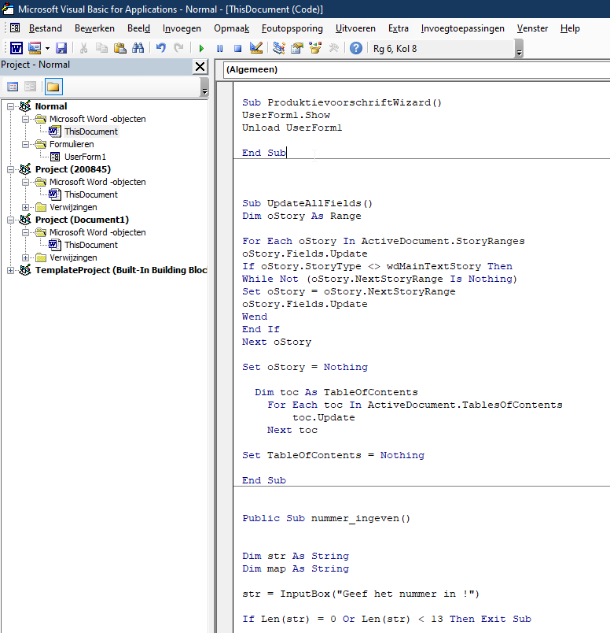

Om de knoppen te hebben in het lint

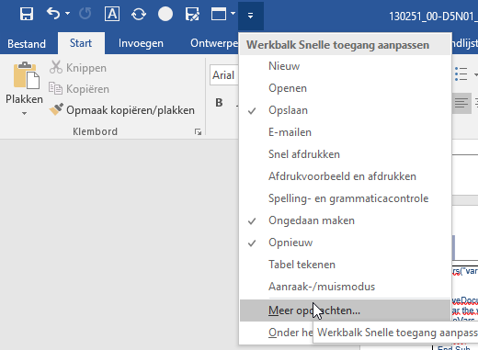

Macros kiezen en je kan ze toevoegen en een icoontje aan toekennen

